Roll No. .......................................
MATM2215T: MATHEMATICAL METHODS
Maximum Marks: 70 Time Allowed: -3 Hrs.
Note:- Candidates are required to attempt Two question from each section A and B & entire section C
Section A
Q.1 Discuss the Solution of Fredholm Integral Equation of The Second Kind by Successive Substitutions. 10
Q.2 (i) Find the eigen values and eigen functions of homogeneous integral equation
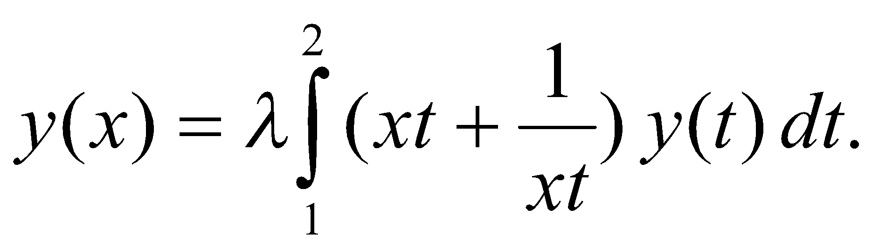 5
_{(ii)} Solve the Volterra integral equation of second kind 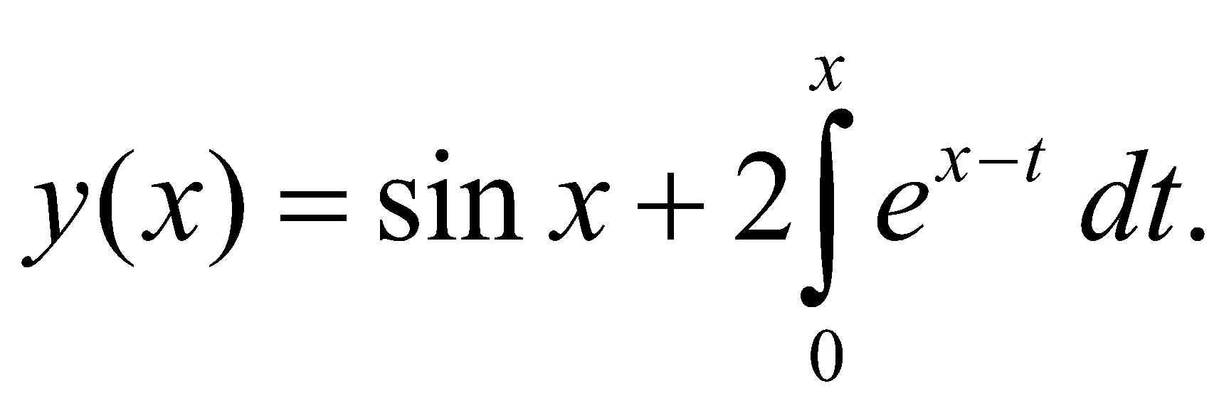 5
Q.3 (i) State Schwarz’s Inequality. Give its one application. 5
(ii) State and Prove Hadmard Theorm. 5
Q.4 (i) Find the Solution of the Abel Integral Equation namely, f(x)= where f (x) is a known function while y (t) is to be determined. 5
(ii) Explain Fredholm solution of Drichlet’s Problem 5
Section B
Q.5 (i) .Determine the necessary condition for function y(x) for which the integral
takes the maximum or minimum value. 5
(ii) Explain fixed end point problem for n-variables. 5
Q.6 (i) Find Geodesics of Right Circular Cylinder. 5
(ii) Find the extremals of the functional 5
Q.7 (i) Prove the invariance of Euler’s Equation under coordinate transformation 5
(ii) Find the plane curve of fixed parameter and maximum area. 5
Q.8 (i) Find extremals of 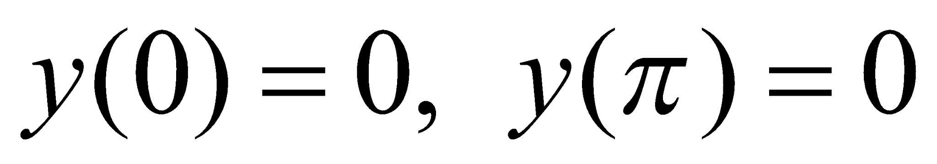 5
(ii) Explain the problem of minimal surface of revolution. 5
Section C
Q.9
- Verify that 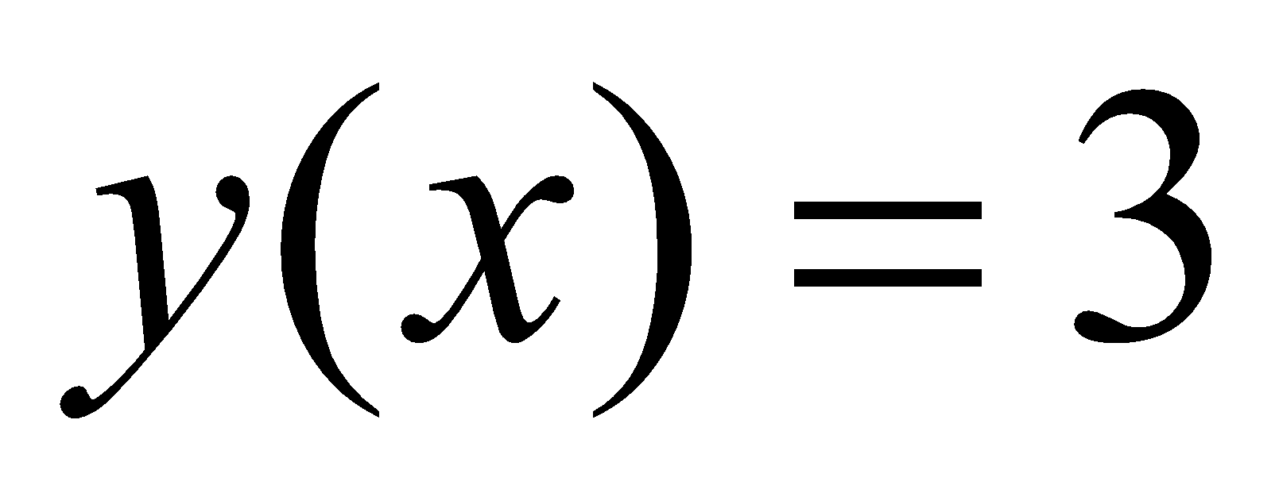 is the solution of 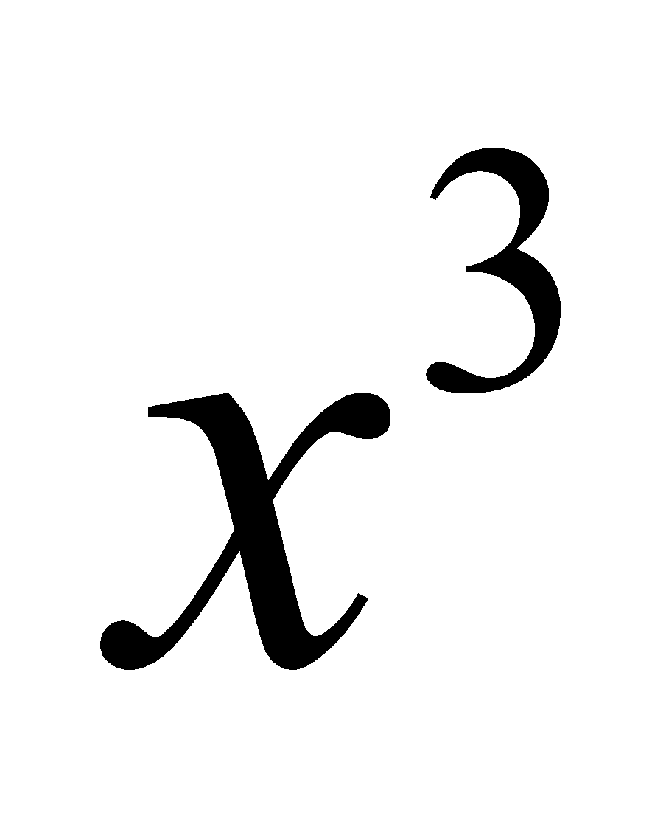=y(t) dt
- Solve 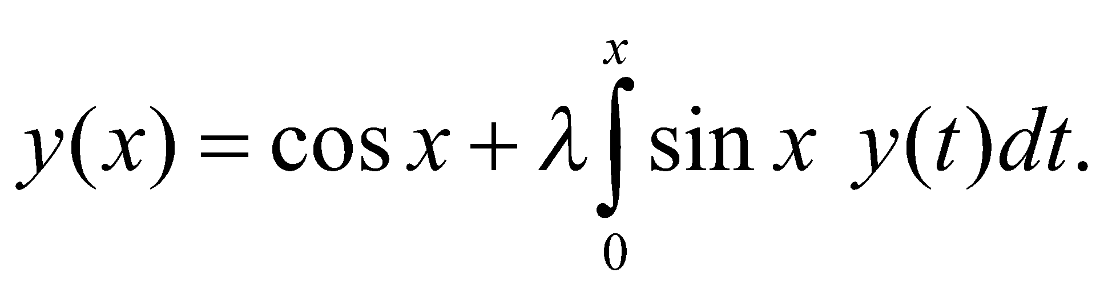
- Find the shortest distance between 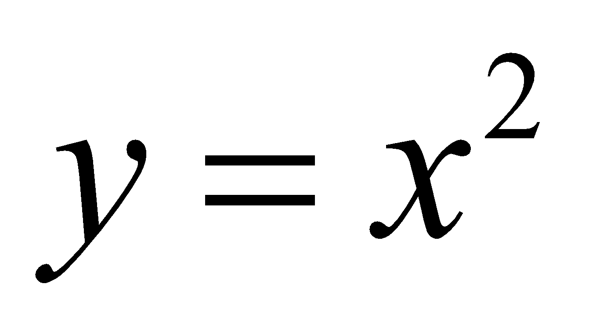 and 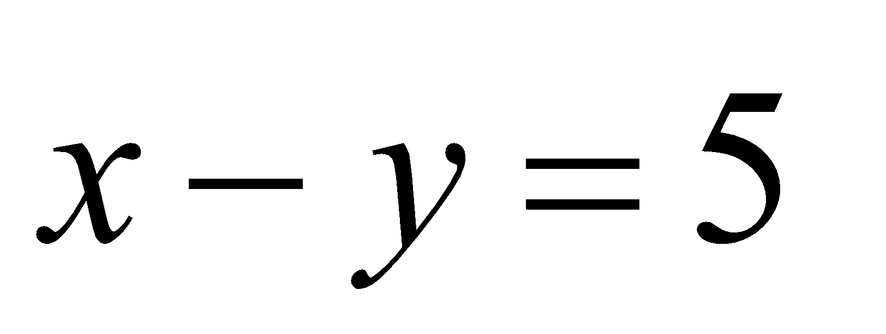
- Prove D(λ) is convergent series
- Define Reciprocal Kernel
- State the problem of Branchistochrone.
- State Abel’s problem
- Find the extremal of
- Derive Euler’s Lagrange equation when f is independent of x and y.
- Write the necessary condition for to be extremum. 10 x 3=30

